A9 - Legal and Regulatory Analysis

Year: 2025 Semester: Spring Team: 9 Project: Fairway Finder

Creation Date: 03/25/2025 Last Modified: March 29, 2025

Author: Marcus Good Email: mrgood@purdue.edu

Assignment Evaluation: See the Rubric in the Brightspace Assignment

Regulatory Analysis

The Fairway Finder robot has multiple components that must comply with government regulations to allow our product to be sold. For an initial entry to the market the group has decided to focus on the largest golfing market (by spending power) in the world as it makes up a significant portion of the entire market. This market being the United States valued at $11.7 billion, while the next two largest markets (Japan, South Korea) combined are $3.3 billion [1]. This will also reduce the sheer amount of initial government regulations the group would have to comply with to bring the product to market. This will allow our product to reach its most significant market faster. In addition, complying with government regulations to expand to future markets can be worked in parallel while the product is being sold in the United States.

To bring our product to market in the United States it must comply with the following regulations:

Mandatory Compliance

Federal Communications Commission (FCC) Part 15

Mercury-Containing and Rechargeable Battery Management Act

EPA Hazardous Waste Disposal Rules (RCRA, 40 CFR Part 261)

Restriction of Hazardous Substances (RoHS) for California & other states

The following standards are not technically required but in practicality will need to be satisfied:

Optional but extremely helpful:

Underwriters Laboratory (UL) Electrical Safety

Bluetooth Special Interest Group (SIG) Qualification

1.1 FCC Part 15 Compliance

FCC Part 15 regulations apply to any devices that communicate via radio frequency (RF) or unintentionally generate electromagnetic interference (EMI). Fairway Finder uses RF through its Bluetooth and Global Navigation Satellite System (GNSS) communication system and unintentionally creates EMI through high frequency oscillators and digital circuits. Therefore, according to the FCC our product is an intentional radiator [2]. As our product is an intentional radiator it will have to have its RF systems tested in a laboratory and then have those results sent to a Telecommunications Certification Body (TCB) to review them. To find an TCB the group will use the following link, https://apps.fcc.gov/oetcf/tcb/reports/TCBSearch.cfm, and send them our testing results. After approval from the TCB is received, the FCC will issue an ID, and then the group will ensure the FCC ID will be displayed on the product. See figure 1 below for a flowchart on FCC Part 15 certification compliance with more detailed steps [3].

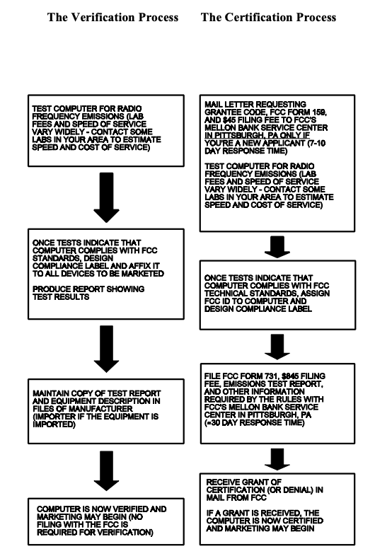

Figure 1: FCC Part 15 Verification and Certification Steps

Battery Management Regulations

The Fairway Finder robot uses a lead acid battery. The Mercury-Containing and Rechargeable Battery Management Act was passed in 1996 and regulates lead-acid batteries in the U.S. specifically the lead portion of the battery. To comply with the act the group will need to do the following according to the EPA [5]:

Labeled to inform consumer of lead content

Labeled battery must be properly recycled and/or disposed

Provide clear instructions to consumers with how to recycle or dispose the battery

Any further state-specific regulations

Maintain records of battery sales and recycling/disposal activities

Hazardous Waste & RoHS Regulations

To comply with the EPA Hazardous Waste Disposal Rules (RCRA, 40 CFR Part 261) and Restriction of Hazardous Substances (RoHS) for California & other states the following general steps will need to be taken:

Restriction of Hazardous Substances (RoHS) Compliance Steps from 40 CFR Part 261 [8]

Conduct a Toxicity Characteristic Leaching Procedure (TCLP)

Must use EPA/California permitted Treatment, Storage, and Disposal Facilities (TSDF) only

Recycling notices for all electrical components

PCB/Lead Components must be disposed of at certified TSDF sites if above certain lead content limits

Waste Determination: Classify and identify any generated waste from product

EPA Hazardous Waste Disposal Compliance Steps [6]

Recycle Lead-Acid battery through permitted recycler

Keep records battery disposal/recycling

If not recyclable use permitted TSDF only

Underwriters Laboratory Electrical Safety

This certification is not legally required, however major vendors such as Amazon, Walmart, etc. require it sell electrical products on their website. Additionally, to get liability insurance on an electrical product many insurance companies require this certification. Therefore, for the product to be successful it will be needed. General compliance steps are straight forward as can be seen in the figure below.

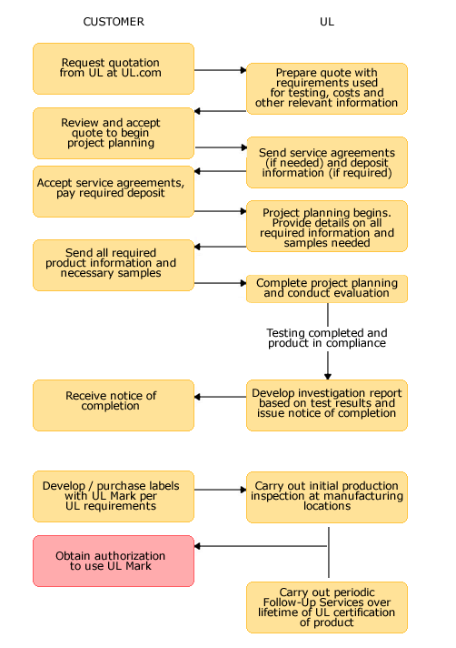

Figure 2: UL Certification Steps [7]

As our group needs electrical safety compliance a review of UL’s “Guide to service robot safety compliance” at this link would needed to make any design/manufacturing changes. After that the group will take the following the steps in the flowchart above to achieve UL’s certification.

1.5 Bluetooth Special Interest Group (SIG) Qualification

Finally, getting the Bluetooth SIG qualification is not necessarily required but will ensure that the product adheres to all Bluetooth specifications through conformity testing and thus will work with any other Bluetooth device. It also allows the group to legally use the Bluetooth trademark in marketing and packaging. In our project as we are using the CC2541 for Bluetooth communication and it has already been certified by the SIG and Texas Instruments we will not need to undergo any testing. However, we would still need to acquire Bluetooth SIG membership and then go through the qualification process [9]. The general steps for qualification are to create a qualification declaration with the SIG which demonstrates compliance with the Bluetooth’s standard specifications. Then, SIG will review the declaration and if satisfactory with the standard, will list the product on the Bluetooth SIG website. Finally, the product can use the Bluetooth trademark and both us and consumers can be confident it will work with all Bluetooth devices.

2.0 Legal Liability Analysis

Analysis of Patent 1, US Patent Application 9869999 B2 [10]:

Filing Date: October 14, 2016

Abstract: This patent outlines a robot golf caddy that is able to navigate by tracking a portable receiver carried by the user, carry a user’s golf bag. It also has obstacle avoidance detection so the robot can sense an obstacle and stop itself to prevent a collision.

Key Patent Claims for Potential Infringement: The physical design of the robot and the following algorithm the group is created potentially infringes on the following claims:

A golf caddy having a vehicle frame with a golf bag cavity. Design has support along the bottom and side for the golf bag

A processor unit that communicates with tracking receiver system and processes the signal to find the position of the remote transmitter relative to the golf caddy

A processor unit determine how to move the golf caddy relative to the remote transmitter

A drivetrain connected to the vehicle to move the golf caddy

The processor unit claims the use of a remote tracker and from that calculates the position of the tracker relative to the robot is on a high level similar to the functionality of the group’s following algorithm. However, we are not using a remote tracker but the user’s phone GPS. Therefore, while similar because we are not creating a remote tracker and using that to calculate the user’s position versus the robot, we do not believe there is any doctrine-of-equivalents infringement. Additionally, the control to define how to move the robot will be inherently different because of the use of a RF signal from their receiver versus our GPS signal. Carrying the golf bag with bottom and side support is something that our group’s pushcart does as well however, the design of their robot’s support system is significantly different from our groups design as it has a large lower base cavity and does not have geometry very similar to our solution, see figure 3 below for their robot chassis design. Therefore, the group does not see any patent infringement. Finally, the drivetrain on their robot is also significantly different than our groups design, the wheel spacing, the wheel geometry, the battery capacity, and size of the wheels are all different. Therefore, we do not see any patent infringement.

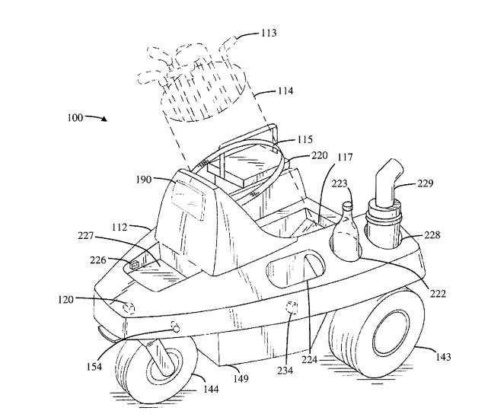

Figure 3: Robot Chassis Design

Analysis of Patent 2, U.S. Patent Application 20100168934 A1 [11]

Filing Date: May 17, 2007

Abstract: A robotic vehicle with its own drivetrain system that can act as a golf caddy, robotic lift assistant or transport vehicle. It will avoid collisions with obstacles and will not steer into a collision path with obstacles. It will follow a remote receiver and can sense unsafe gradients.

Key Patent Claims for Potential Infringement:

A self-propelled robotic vehicle response to RF signal from a transmitter

A drive mechanism supported on the vehicle frame and adapted to receive and act on electrical signal sent from the processor to move the vehicle relative to the transmitter

A system for self-propelled robotic vehicle including

A transmitter able to transmit a RF signal

A self-propelled vehicle including vehicle frame

At least two spaced apart receivers adapted to receive signal from the transmitter

These two claims on the patent are very similar to each other and what our group is trying to achieve. Our group will also be using a RF signal from a transmitter from the users phone to control our devices drive mechanism based on an electrical signal from a processor. However, this patent explicitly specifies using two spaced apart receivers to properly acquire the signal from the transmitter. This is a significant design difference from our robot as it only has 1 receiver and is using a GNSS and/or Bluetooth receiver separately not as a pair. Therefore, while similar we do not believe any functional patent infringement.

Analysis of Patent 3, U.S. Patent Application 5711388A [12]

Filing Date: July 17, 1996

Abstract: An autonomous service robot that includes a digital computer with digital storage, that stores a digital map and navigation rules. Also includes a GPS tracking system and uses sensors to dynamically detect obstacles. The robot can adjust its path based on the golfer’s location and any obstacles in the way to ensure the robot acts in a safe manner. These functionalities are well suited to have the robot act as a golf caddy.

Key Patent Claims for Potential Infringement:

An autonomous robotic apparatus with a computer control assembly, a communication assembly connected to the computer assembly that uses a combination of GPS satellites and a ground receiver to find the robot’s location

The robot receives a signal from the golfer’s transmitter to be receiver by the communications assembly and in combination with the stored map issues control commands

The first claim of using a communications assembly to determine the robot’s GPS location is very similar to how we are determining our robot’s location. We are using a GNSS module that can use either the GPS or any other navigation satellite constellation to find our robot’s coordinates on Earth. However, as this patent covers locating the user from a RF signal and does not claim that it is using a GNSS module to calculate how to follow the user we have a significant difference. We are not tracking the RF signal to know how to allow the robot to navigate, we are simply using the RF signal to communicate the user’s position that their smartphone’s GNSS module determined. From the we are taking the coordinate difference and outputting the control commands to the robot’s drivetrain. Therefore, we do not believe there is any patent infringement.

3.0 Sources Cited:

[1] Mordor Intelligence, "Golf Equipment Market - Size, Analysis - Industry Share by Brand," Mordor Intelligence, 2025. [Online]. Available: https://www.mordorintelligence.com/industry-reports/golf-equipment-market
[2] Federal Communications Commission, "RF device," Office of Engineering and Technology. [Online]. Available: https://www.fcc.gov/oet/ea/rfdevice. [Accessed: Mar. 29, 2025].
[3] Federal Communications Commission, "OET Bulletin 62: Evaluation of the environmental effects of radiofrequency radiation," Office of Engineering and Technology, rev. Aug. 1997. [Online]. Available: https://transition.fcc.gov/Bureaus/Engineering_Technology/Documents/bulletins/oet62/oet62rev.pdf. [Accessed: Mar. 29, 2025].
[4] RohsGuide, "ROHS certification," RohsGuide. [Online]. Available: https://www.rohsguide.com/rohs-certification.htm. [Accessed: Mar. 29, 2025].
[5] U.S. Environmental Protection Agency, Lead-Acid Battery Recycling (EPA 530-K-94-004), Mar. 1994. [Online]. Available: https://www.epa.gov/sites/default/files/2016-03/documents/p1104.pdf. [Accessed: Mar. 29, 2025].
[6] U.S. Government, "49 CFR § 173.159 - Requirements for the transportation of lead-acid batteries," Electronic Code of Federal Regulations, [Online]. Available: https://www.ecfr.gov/current/title-49/subtitle-B/chapter-I/subchapter-C/part-173/subpart-E/section-173.159. [Accessed: Mar. 29, 2025].
[7] UL, "Preparing for your UL Mark evaluation in the U.S. and Canada," UL, [Online]. Available: https://www.ul.com/resources/preparing-your-ul-mark-evaluation-us-and-canada. [Accessed: Mar. 29, 2025].
[8] U.S. Government, "40 CFR Part 261 - Identification and listing of hazardous waste," Electronic Code of Federal Regulations, [Online]. Available: https://www.ecfr.gov/current/title-40/chapter-I/subchapter-I/part-261. [Accessed: Mar. 29, 2025].
[9] Ezurio, "The latest Bluetooth SIG qualification process is official: Here’s what you need to know," Ezurio, [Online]. Available: https://www.ezurio.com/resources/blog/the-latest-bluetooth-sig-qualification-process-is-official-here-s-what-you-need-to-know#:~:text=The%20Bluetooth%20Qualification%20Program%20has,document%20called%20the%20Qualification%20Program. [Accessed: Mar. 29, 2025].
[10] Dennis W. Doane, "Robotic Golf Caddy”, U.S. Patent 9,869,999. [Online]. Available: https://patentimages.storage.googleapis.com/20/84/74/41acff5ae60473/US9869999.pdf. [Accessed: Mar. 29, 2025].
[11] David Charles Ball, “ROBOTIC GOLF CADDY”, U.S. 20100168934A1. [Online]. Available: https://patentimages.storage.googleapis.com/bc/cf/9c/581f0d90f6696b/US20100168934A1.pdf. [Accessed: Mar. 29, 2025].
[12] Ronald C. Davies, “Robotic golf caddy apparatus and method”, U.S. Patent 5,711,388. [Online]. https://patentimages.storage.googleapis.com/a4/d4/80/59be4ba19af482/US5711388.pdf. [Accessed: Mar. 29, 2025].

